Hydrological Monitoring Report

{{ report_date }}

## 

## 

## 

## 

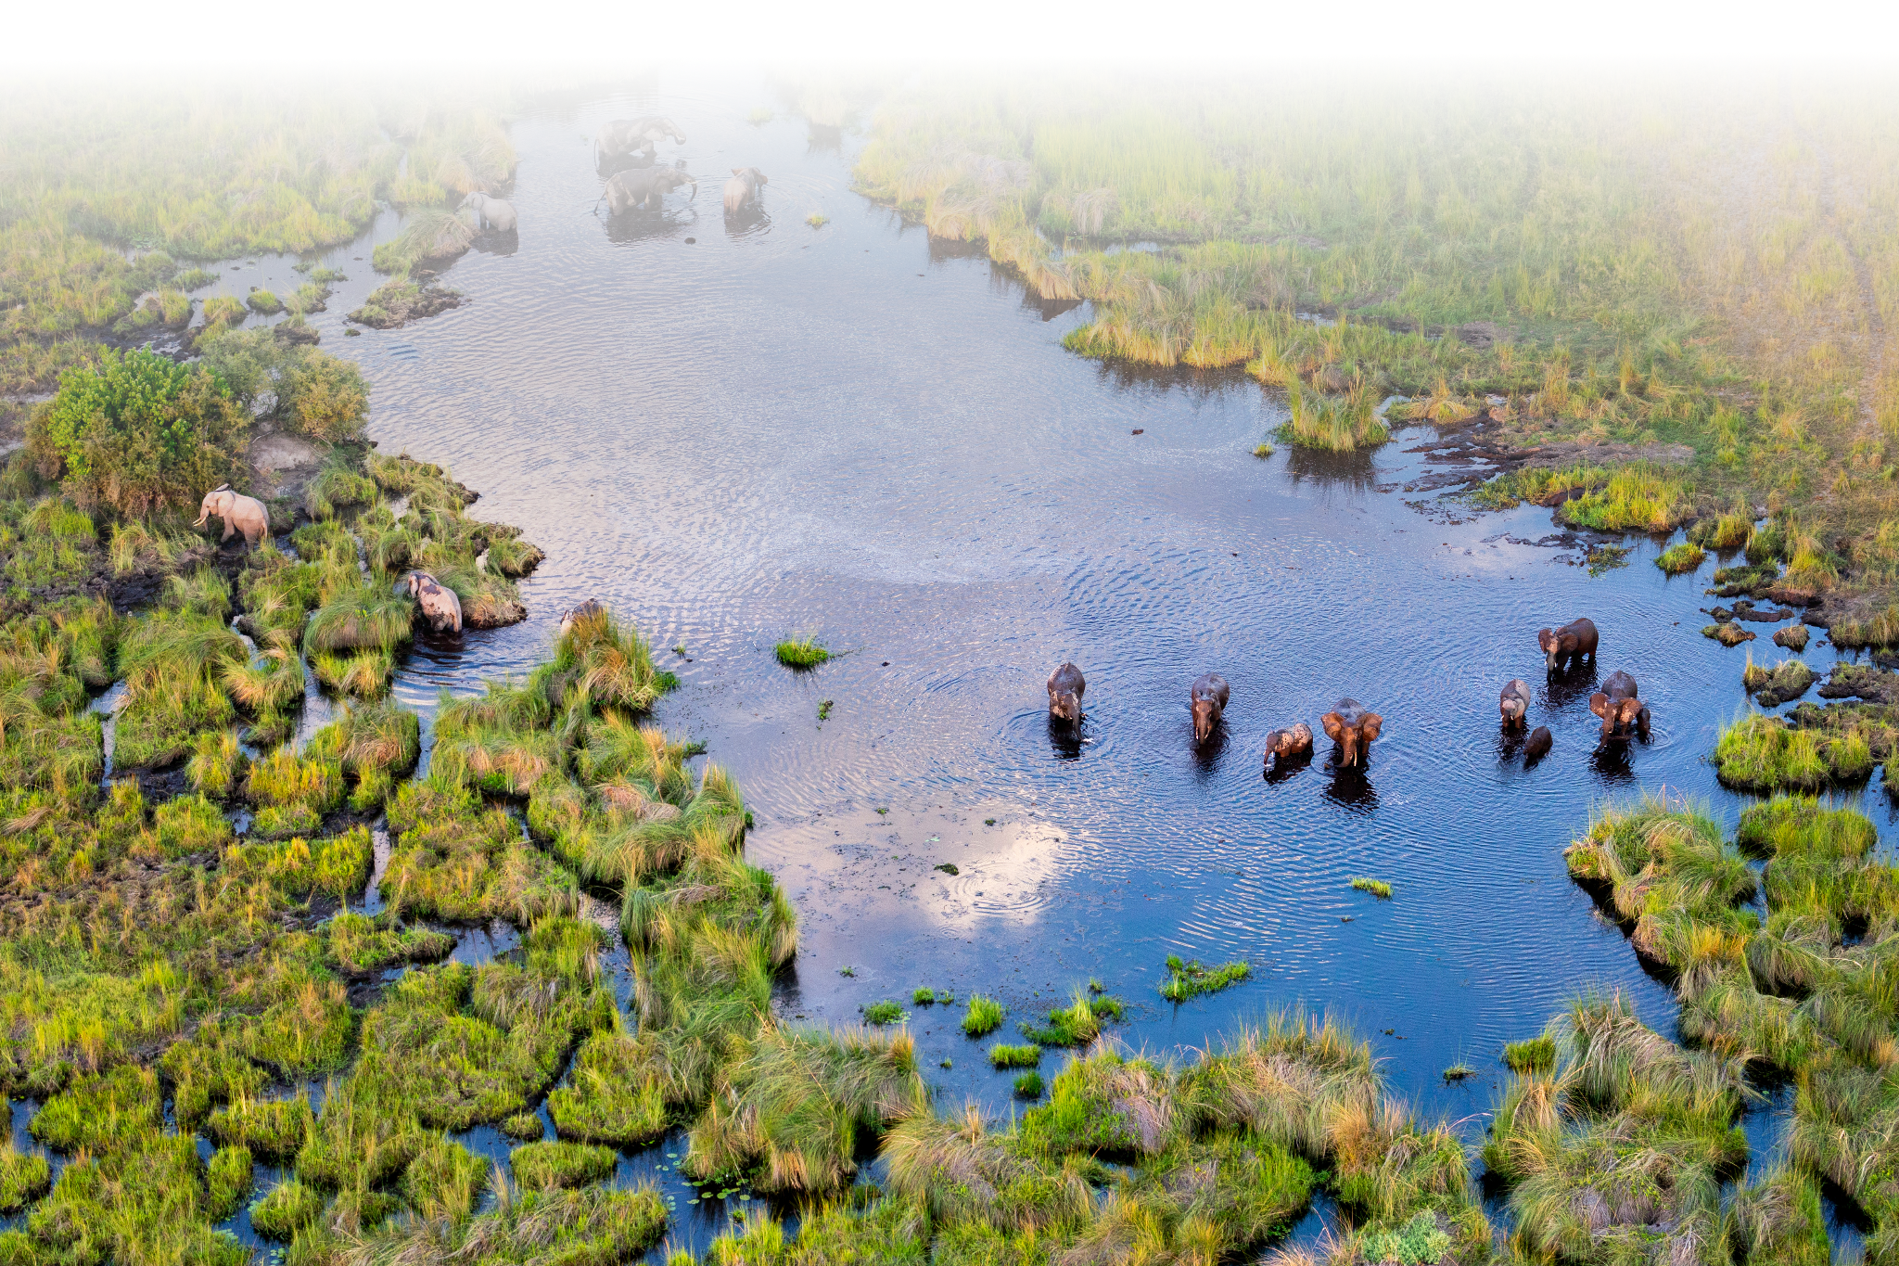

## River Depth

{% for chart in depth_chart %}{% if chart.title %}{{ chart.title }}{% endif %}{{ chart.image }}

{% endfor %}

## Dissolved Oxygen

{% for chart in do_chart %}{% if chart.title %}{{ chart.title }}{% endif %}{{ chart.image }}

{% endfor %}

## Daily Summary

{% for item in summary %}{% if item.title %}{{ item.title }}{% endif %}

|  |  |  |  |
| --- | --- | --- | --- |
|  | {%tc for col in item.col_labels %} | {{ col }} | {%tc endfor %} |
| {%tr for row in item.tbl_contents %} |  |  |  |
| {{row.label }} | {%tc for col in row.cols %} | {{ col }} | {%tc endfor %} |
| {%tr endfor %} |  |  |  |

{% endfor %}